**Department of Electrical and Computer Engineering**

**North South University**



**Senior Design Project**

**IoT Based Home Automation Solution with Energy Monitoring Features.**

**Noor Al Din Ahmed ID # 1310607043**

**Rahatul Aine ID # 1220812042**

**Faculty Advisor:**

**Dr. Tanzilur Rahman**

**Assistant Professor**

**ECE Department**

**Fall 2017**

**LETTER OF TRANSMITTAL**

December, 2017

To

Dr. Mohammad Rezaul Bari

Associate Professor and Chairman,

Department of Electrical and Computer Engineering

North South University, Dhaka

**Subject:** Submission of Capstone Project on “IoT Based Home Automation Solution with energy monitoring features”.

Dear Sir,

With due respect, we would like to submit Our **Capstone Project Report** on “IoT Based Home Automation System with energy monitoring features”as a part of our BSC program. The report deals with an IoT based Home Automation system which enables users to control their home appliances through a web interface. We tried our level best to make the report meaningful and informative.

The Capstone project was very much valuable to us as it helped us to gain experience from practical field. It was a great learning experience for us. We tried to the maximum competence to meet all the dimensions required from this report.

We will be highly obliged if you are kind enough to receive this report and provide your valuable judgment. It would be our immense pleasure if you find this report useful and informative to have an apparent perspective on the issue.

Sincerely Yours,

.........................................................

Noor Al Din Ahmed

ECE Department

North South University, Bangladesh

........................................................

Rahatul Aine

ECE Department

North South University, Bangladesh

**APPROVAL**

The capstone project entitled **“IoT Based Home Automation Solution with energy monitoring features**” by Noor Al Din Ahmed ( ID # 1310607043) and Rahatul Aine (ID # 1220812042), is approved in partial fulfillment of the requirement of the Degree of Bachelor of Science in Computer Science and Engineering on April, 2016 and has been accepted as satisfactory.

**Supervisor:**

**Dr. Tanzilur Rahman**

**Assistant Professor**

Department of Electrical and Computer Engineering

North South University

Dhaka, Bangladesh.

**DECLARATION**

This is our truthful declaration that the **“Capstone Project Report”** we have prepared is not a copy of any **“Capstone Project Report”** previously made by any other team. We also express our honest confirmation in support of the fact that the said **“Capstone Project Report”** has neither been used before to fulfill any other course related purpose nor it will be submitted to any other team or authority in future.

.........................................................

Noor Al Din Ahmed

ECE Department

North South University, Bangladesh

........................................................

Rahatul Aine

ECE Department

North South University, Bangladesh

**ACKNOWLEDGEMENT**

First of all, we wish to express our gratitude to the Almighty for giving us the strength to perform our responsibilities and complete the report.

The capstone project program is very helpful to bridge the gap between the theoretical knowledge and real life experience as part of Bachelor of Science (BSc) program. This report has been designed to have a practical experience through the theoretical understanding.

We also acknowledge our profound sense of gratitude to all the teachers who have been instrumental for providing us the technical knowledge and moral support to complete the project with full understanding.

We would like to convey our gratitude to our faculty **Dr. Tanzilur Rahman** for his stimulating inspiration, kind guidance, valuable suggestions, sagacious advice and kind co-operation throughout the period of word undertaken, which has been instrumented in the success of our project. At this level of understanding it is often difficult to understand the wide spectrum of knowledge without proper guidance and advice. His suggestions & guidance have made the report a good manner.

We thank our **friends and family** for their moral support to carve out this project and always offer their support.

**ABSTRACT**

IoT (Internet of Things) based Home Automation system signifies the application of computer technology and internet for controlling the home appliances easily and remotely from any place in the world. As technology is evolving day by day and almost every equipment is getting automated, so there is seen a gradual increase amounts of automation in homes around the world because it reduces human labor and provides ease and comfort in people’s busy lives. Our project represents a semiconductor based Home Automation system which can control the switching of the power outlets in terms of controlling various electrical appliances, such as lights and fans or any inductive load that can be voltage regulated and switching various devices on and off. This system contains a Zero Crossing Detector (ZCD), a Thyristor based switching circuit to control the power output to the loads and also a Web Server along with a database and API functionality since the whole unit needs to be controlled through the web. Although, the Home Automation is becoming popular worldwide, it is not vastly being used in Bangladesh because establishing a Home Automation system seems very costly to the majority of people in here and besides, many people here are still not technologically literate where they cannot directly interact with computers. Thus, our proposed system brings a solution to this problem which is affordable, convenient and simple and requires minimal knowledge for users to operate it. This system can not only be implemented in residential buildings but also can be used in office buildings, hospitals etc to manage certain room conditions.

Table of Contents

**Chapter 1: Introduction 5**

1.1 Overview 6

1.2 Why Home Automation? 7

1.3 History of Home Automation 7

1.4 Project Aim and Objective 9

1.5 Motivation 11

1.6 Thesis Outline 12

**Chapter 2: Literature Review 14**

2.1 Overview 15

2.2 Existing literature explanation 15

2.3 Status of Home Automation in terms of global and our country aspect 17

2.4 Summary 20

**Chapter 3: System Design Plan 21**

3.1 Overview 22

3.2 System Architecture 22

3.3 Hardware Architecture 23

3.4 Software Architecture 24

3.5 Summary 25

**Chapter 4: Methodology and Implementation 26**

4.1 Overview 27

4.2 Hardware and Software Requirements 27

4.3 Hardware 27

4.3.1 Zero Crossing Detector (ZCD) 27

4.3.2 TRIAC Dimmers 32

4.3.3 Current sensor 35

4.3.4 Voltage sensor 37

4.3.5 Arduino Pro Mini 38

4.3.6 ESP8266 39

4.4 Software 41

4.4.1 Web application 41

4.4.2 Communication 43

4.4.3 Measuring the frequency of AC signal using Zero Crossing Detector 43

4.5 Hardware Implementation 44

4.6 Software Implementation 46

4.7 Summary 48

**Chapter 5: Results and Testing 49**

5.1 Overview 50

5.2 Zero Crossing Detector 50

5.3 TRIAC circuit 54

5.4 Current Sensor 54

5.5 Simulation 55

5.6 Issues 57

5.7 Summary 58

**Chapter 6: PCB Design 59**

6.1 Overview 60

6.2 PCB Designs 60

6.2.1 Zero Crossing Detector and TRIAC circuit: 60

6.3 Perf Board Designs: 62

6.3.1 Current and Voltage Sensors: 63

6.3.2 Arduino and ESP8266: 64

6.4 Summary 65

**Chapter 7: Device Specification and Installation 66**

7.1 Overview 67

7.2 Features: 67

7.3 Specifications 67

7.4 Setup 68

7.4.1 Understanding the indoor wiring 68

7.4.2 Electrical Safety 69

7.4.3 Installation Guide 69

7.4.4 Performance 71

7.5 Summary 71

**Chapter 8: Discussion 72**

8.1 Overview 73

8.2 Cost Analysis 73

8.3 Future work 74

8.4 Limitations 76

8.5 Conclusion 76

**APPENDIX 77**

Arduino Code: 78

ESP8266 Code: 83

**References 89**

Chapter 1: Introduction

# Overview

In today’s world everything is becoming modernized and almost everything is being controlled electronically and wirelessly. Keeping with the trend, the world at present is seeing increased amounts of automation in homes. Home automation usually signifies increased automation of household appliances through electronic means that allow for things impracticable, overly expensive or simply not possible in recent past decades. Home automation gives us access to control devices in our home from mobile device anywhere in the world. Home automation more accurately describes homes in which nearly everything, such as; lights, fans, appliances, electrical outlets etc are hooked up to a remotely controllable network. However, many techniques used in building automation (such as light and climate control, control of doors and window shutters, security and surveillance systems, etc.) are also used in home automation, additional functions in home automation include the control of multi-media home entertainment systems, automatic plant watering and pet feeding, smart appliances such as; refrigerators, dryers, washers, lighting etc, smart security systems (sensors, monitors, cameras, alarms systems etc) and automatic scenes for dinners.

The home automation system is not as expensive as it used to be but it is still quite costly and for that it has not been extensively implemented in a developing country like ours. Hence we took on task of making a project which would involve automation of homes at a reasonable price with parts that are available within our country. Our IoT project focuses on building a wireless home automation system to which users can get connected remotely and can access and control the appliances of their home through the internet. The users can also be able to see the status of their appliances on their phones, for example, whether a light is switched ‘on’ or ‘off’, by using this wifi connected microcontroller managed system and be notified.

In this chapter we are going to explain, why home automation is needed, history of home automation, our project aim and objectives and its benefits and our motivation for doing this project.

# Why Home Automation?

The concept of the “Internet of Things” has tied closely with the popularization of home automation. IoT based home automation refers to the application of computer and information technology for control of home appliances easily from remote places. This IoT based home automation system allows us to program devices on the network and to remotely connect and monitor real object (things) through the internet. Home automation can provide increased quality of life for the elderly or disabled persons who need caregivers and it also can offer the comfort and security for the private home’s residents. Basically, Home Automation can make our life a lot easier and safer.

# History of Home Automation

The idea of Home Automation has been around for a long time. For decades, science fiction has explored the idea of home automation. This timeline below explains from the early inventions of home automation leading up to the smart homes we know today. [1]

**1785 – The invention of remote control:** Nikola Tesla invented the first remote control which could control a toy boat.

**1901 – 1920 – The invention of Home appliances:** The 20th century started with the invention of the first home appliances. The first engine-powered vacuum cleaner was invented in 1901. Then a more practical electricity-powered vacuum was invented in 1907. Throughout the two decades refrigerators were invented as well as clothes dryers, washing machines, toasters and so much more.



Figure 1.1: IoT based Home Automation and its applications

**1966 – 1967 -** **ECHO IV and the Kitchen Computer** –  The ECHO-IV was the first smart device which could compute shopping list, control the home’s temperature and turn appliances on and off. The kitchen computer was invented a year later which could store number of recipes. But unfortunately these two products were never commercially sold.

There were many more advances after that but things moved slowly. The idea of smart home finally came around in 1984.

**1998 – Early 2000s:** **Smart Homes** – In the early 2000s, different technologies began to emerge. Smart homes, or home automation, began to increase in popularity in the early 2000s. Smart homes suddenly became a more affordable option and became a viable technology for consumers. Domestic technologies, home networking, and other gadgets began to appear later in market

**Today’s Smart Homes** - Today’s smart homes are more about security, comfort and convenience. Today’s smart homes are sustainable, and they help to ensure that our homes aren’t expending unnecessary energy. They also help alert us to intruders (whether we’re home or not). Current trends in home automation include remote mobile control, automated lights, automatic thermostat adjustment, scheduling appliances, mobile/email/text notifications, remote video surveillance and many more. Current home automation system provides mobile apps for users to control home appliances remotely through internet. In addition, current home automation system provides the facility for users to control any load or home device remotely using internet network over the Cloud platform. It provides open API for smart home device to integrate with cloud platform easily.

.

# Project Aim and Objective

As technology is advancing so houses are getting smarter day by day. Modern houses are gradually shifting from conventional switches to centralized control system which involves remote control switches. The conventional switches located in different parts of the house makes it difficult for the users to go near them and operate. Especially, it becomes more difficult for the elderly or physically handicapped people to do so. In this aspect, our proposed system can help people to solve these problems and using this system user can be greatly benefitted.

The points below show our project’s aim and objectives:

* Our aim is to build a Home Automation System that will improve comfort, enhance accessibility, minimize operating costs, simplify use of technologies, and promote energy efficiency and convenience.
* We aim to build a system that will enable people who are out of their homes most of the time to monitor their homes in real time from anywhere in the world.
* Using our system, the physically challenged people can also easily control basic appliances through an already available cell phone using an application.
* Our system can also be used in hospitals to manage certain room conditions.

The main objective of this project is to develop a Home Automation System using an Arduino board which can be remotely controlled by any smart phone. Using this system, users can control their home appliances that can be connected to a local area network, via Ethernet or Wi-fi. The GUI application on the cell phone will send ON/OFF commands to the microcontroller (Arduino Nano) at the receiver where loads are connected. By touching the specified location on the GUI, the loads can be turned ON/OFF remotely through this technology.

# Motivation

In today’s world, most existing solutions in home automation systems lack certain significant features. For example, most existing systems are not affordable for most users due to high costs and difficult maintenance and some systems provide solutions that are not very useful for household applications. Many tasks are repetitive in nature, such as, turning on or off lights, fans or dimming lights manually etc. These tasks can be accomplished on one button using home automation. Many accidents happen in the home because of poor lighting. Sometimes at home, the lights or fans remain switched on unnecessarily when the residents go outside their home. So home automation products can reduce this power consumption, utility bills and automatically turn off lights and appliances when they are not in use. Using IoT based home automation products, users can check the status of their home appliances while they are away without having to worry about whether their room lights or fans are switched on or off.

As most of the home automation devices are very expensive in the market, many people in our country think that it is only meant for the rich and therefore cannot be afforded in their homes. Also, they lack knowledge in this technology and how they will be benefited from it. Therefore, the motivation behind the development of this system is to let people know about these technologies and make the system as simple as possible for an ordinary person to understand and letting them know of the full benefits the home automation can provide to them. Our motivation is to facilitate the users to automate their home having remote access to the appliances and make their life convenient and comfortable.

# Thesis Outline

The entire project is composed of six chapters, each covering a section of the work as summarized below –

* Chapter one gives an introduction to automation as a whole, history of home automation, our project’s aim and objective, it’s benefits and importance and our motivation behind doing this project.
* Chapter two covers an extensive literature review of previous works on home automation system.
* Chapter three is about system design. It includes detail explanation about our hardware architecture and software architecture.
* Chapter four is about methodology and implementation. It provides comprehensive details on both hardware components and communication services used. It also explains the hardware and software requirements for this project.
* Chapter five is regarding results and testing. It gives clear practical details of testing the project design and shows the output results achieved after implementing the design.
* Chapter six provide a complete layout of the PCB for the home automation system that was made using Proteus 8 Professional. It also provides the perf board wirings for the energy measurement module and the combination of Arduin and ESP8266.
* Chapter seven discusses about the device specification, safety and installing of the home automation system in typical households. It also talks about the features and about the things that need to be done after the initial installation.
* Chapter eight is on Discussion. It includes cost analysis about our expenditure made for this project. It also includes the limitations of this project and describes possible future development of this project work.

Chapter 2: Literature Review



# Overview

While working on this research project, we have studied various research papers based on our project topic and selected few papers from there which were conducted on IoT based Home Automation system and Zero Crossing detection technique. We chose these selective papers because their working approach is closely related to our research work and gathered some ideas from there for doing our work.

# Existing literature explanation

Although Home Automation systems are not that common in our country, considerable amount of research and implementations has been done by various authors in various countries. Some of the examples of their work are given below:

* Ravi Kishore Kodali et.al [2] proposed an IoT Based Smart Security and Home Automation System. Where the electrical appliances generally work through only Bluetooth enabled smart phones, which in some contexts cannot be managed from a distant location. In order to modify the existing home automation solutions, the writers proposed a system which can be served as a smart security system and as a smart home automation system as well. The main objective of this IOT based project focuses on building a smart wireless home security system which sends alerts to the owner by using internet in case of any trespass and raises an alarm optionally. And also, the system can be used as home automation by making use of same sensors.

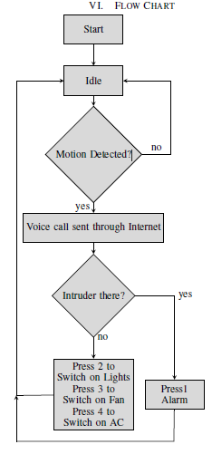

**Figure 2.1:** Flow Chart of IoT Based Smart Security and Home Automation System.

* Kumar Mandula et.al [3] proposed a system where the goal was to apply a solution towards smart governance, smart education, smart agriculture, smart health care, smart homes etc. But this paper explains how this device can be used for smart home automation using microcontrollers (Arduino) along with an Android mobile app. The device will be controlled through Bluetooth in an indoor environment and Ethernet for outdoor environment.
* R. Baris Dai et al [4] proposed dimmer circuit for controlling three different light sources incandescent bulb, CFL and LED. Different kind of light sources are studied and tested with AC and DC sources. Experiments were performed in order to observe the electrical characteristic of the dimmer and optical characteristic of the lighting devices when they are used with the dimmer circuit. The experimental results showed that the proposed dimmer can be used with these kinds of lighting devices within specific output voltage ranges.
* Jong-Hyun Kim et al [5] proposed a simple dimmer using a MOSFET for AC driven lamp such as AC LED and incandescent lamp. The control method of the proposed dimmer is pulse width modulation (PWM) method. Compared with the conventional phase-controlled dimmer, the proposed PWM dimmer can produce sine wave and it does not cause harmonics problem

# Status of Home Automation in terms of global and our country aspect

Technology is evolving decade by decade. In today’s era, technology can enhance human life by combining latest technology with home and can bring comfort and convenience to people’s regular lives. Today with the help of technology and internet, people can build a home automation system which can operate commonly used home devices automatically and can provide convenient life to people.

Earlier automating electrical devices were totally mechanical. For example; lighting systems, air-conditioning systems, television remote control, switching fan, etc. But today, with the invention of computer system, researchers have created computer based intelligent systems such as, touch-screen controlled home automation systems that come up with much functionality. This touch screen controlled system has a graphical user interface such as, buttons, icons, images etc and by touching on these buttons or icons, users can give commands and automate the control of electrical devices at home. Using this computer based home automation system or touch-screen controlled home automation system, users can operate their regularly used home appliances such as, lights, fan, AC, TV etc remotely which can reduce people’s hard labor in performing these day-to-day activities and can accelerate the working speed of users.

Nowadays, as technology is advancing at rapid pace, new technologies are being introduced into homes worldwide. The high-tech gadgets are making homes smarter today. There has recently been observed a significant rise in the number of smart home connected devices compared to the earlier times. In 2015, there were 111.5 million connected households worldwide, with North America having the highest rate of 23 percent. Europe is the second fastest growing region in terms of the number of smart homes. Asia-Pacific is still in the beginning stage in terms of experiencing smart homes, but the market is expected to grow quickly after 2018.

In recent times, the Zigbee home automation market is getting popular internationally. Zigbee is a wireless technology (it’s widely considered an alternative to WI-FI and Bluetooth) which aims to provide the foundation for IoT with features to support low-cost, highly reliable networks for device-to-device communication. Zigbee-enabled devices in home automation allow the devices to work and operate together while also giving users the ability to control them. Report says, the global Zigbee home automation market is likely to increase at an annual rate of 26 percent from 2016 to 2020. [6]

With the development and rapid growth of technologies, the people in Bangladesh are gradually being introduced to the latest technologies, such as; smart phones, computers etc. But the current scenario in Bangladesh in terms of smart homes use, is not very notable. Here, many people in our country are still not technologically literate; they are not very familiar with computers and cannot directly interact with computers. This is why they are not aware of the flexibility and convenience that a home automation system can bring into their lives. Moreover, establishing a home automation system seems very costly to many people in here. However, effective initiatives are being taken to remedy this situation here. ICT-based education is being implemented in the primary to tertiary level in Bangladesh, cost of technologies and internet usage is gradually decreasing and quick expansion of wireless internet service is being seen nationwide.

The Ezzy Automations Ltd. is the first Home Automation solution provider in Bangladesh enabling people to establish and utilize the home automation system at their homes. They are providing a home automation service to people which allows users to access their home systems remotely from anywhere and also their automation service enables the automatic control of commonly used home appliances such as, lighting, temperature, security and other home devices. Ezzy group in Bangladesh has developed a nationwide network and their automation solution includes lighting automation, home automation, security automation etc. Through their home automation service, they are bringing comfort in people’s home life, reducing human effort and transforming the definition of way of their living. Gradually, the market of Ezzy automation group will be expanding nationwide in the coming years. [7]

# Summary

In this chapter, we have explained about other researchers’ working method on the topic of ‘Home Automation system’ and ‘Zero Crossing detection’ whose approach is quite similar to our project work and discussed how their working strategy helped us gain some ideas to solve some problems in our project. Here, we have also discussed about how Home Automation is becoming popular everywhere, provided some statistics on the implementation of Home Automation system worldwide and explained the reasons why it is not being extensively used in our country. We also mentioned a company named ‘Ezzy Automations Ltd.’ which made the people in Bangladesh introduce to the Home Automation system for the first time.

Chapter 3: System Design Plan



# Overview

This chapter explains the design of our proposed system which has been shown in the block diagrams. The ideas were first established on pen and paper and then rough circuits were drawn. A low-cost, efficient and user friendly microcontroller based Home Automation System has been presented in our design. The system incorporates the use of microcontroller as a control module and uses internet (IoT) for wireless communication between the remote devices and the control module. Our system will allow the users to control and monitor the connected devices inside the home.

# System Architecture

Our system has two main modules: the hardware interface module and the software communication module. This section is divided into two sub-sections. First sub-section describes the hardware interface module of the system with a block diagram and the second sub-section explains the software communication module in a block diagram.

# Hardware Architecture

The Figure 3.1 shows a block diagram representation of our proposed system (the hardware section).

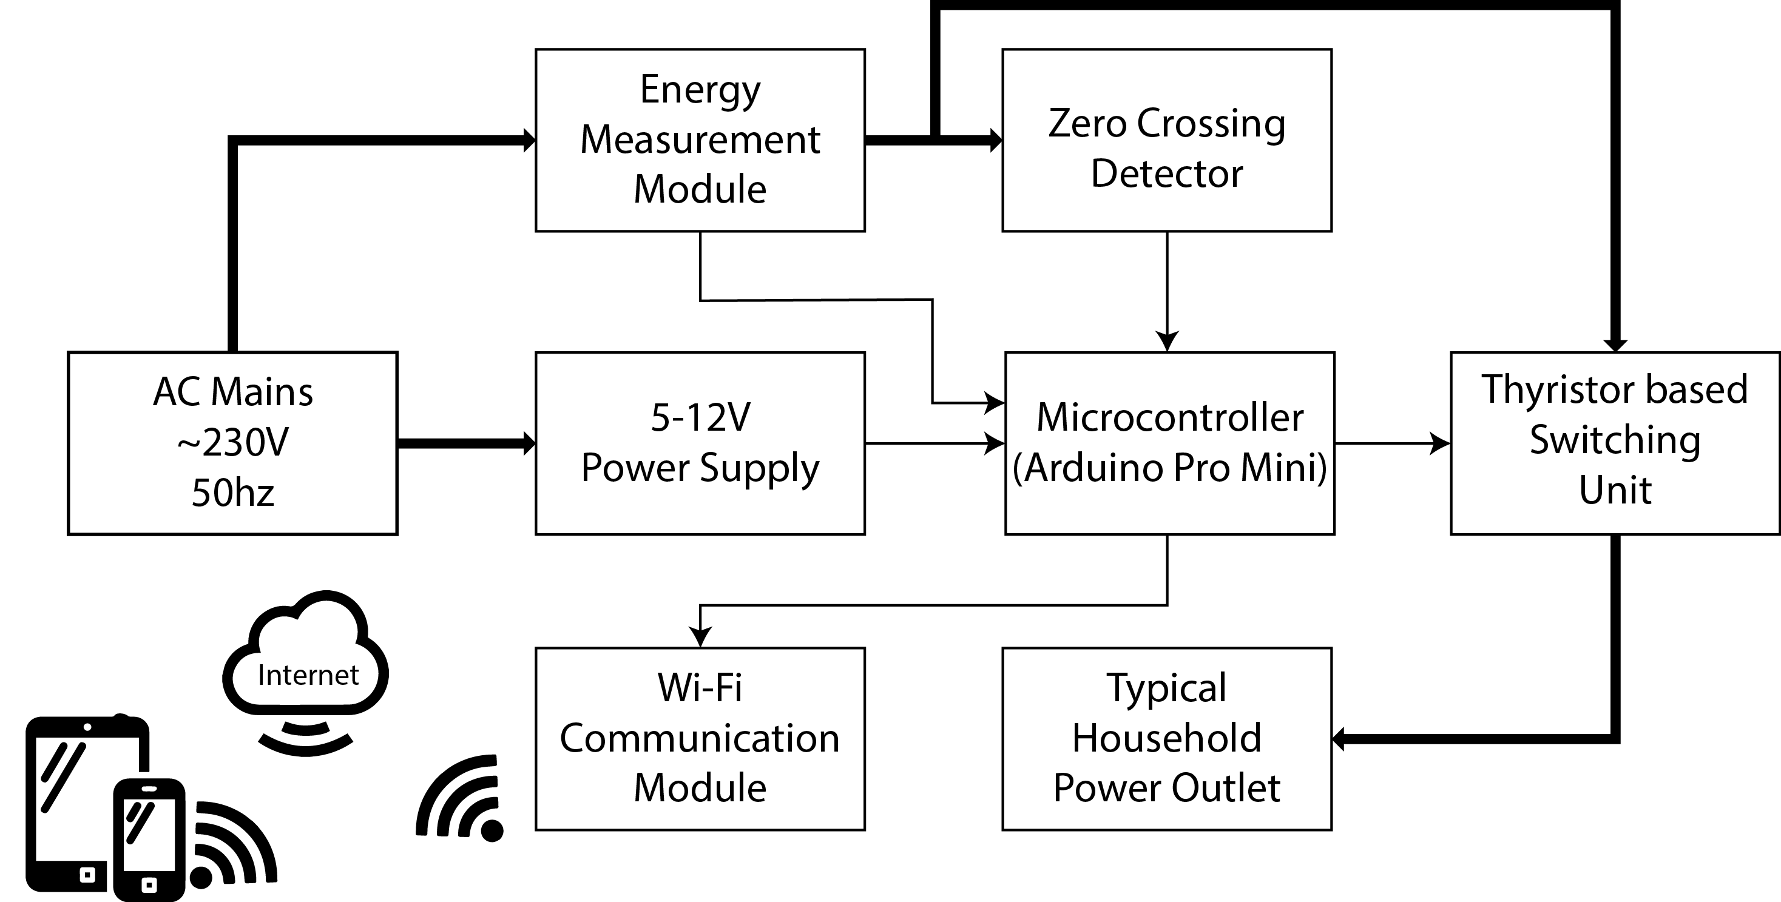

**Figure 3.1: The home automation unit block.**

In our system, the device will be controlled through Wi-Fi in an indoor network hub that is connected to the internet. The system will be connected as follows: At the heart of this system, there will be a Microcontroller (Arduino Pro Mini) which can also be capable of functioning as the interface for all the hardware modules. All communication and controls in this system will pass through the microcontroller. The Microcontroller (Arduino Pro Mini) will detect the phase of the AC signal through the Zero Crossing Detector (ZCD) and control the conduction cycle of the AC signal on the output of the Thyristor based switching unit. With the help of a ZCD, users can regulate the amount of power to output to the lights and Fan through the unit, besides having the capability of completely switching them on and off. The user will also know how much power is being consumed by the devices.

The microcontroller will be connected to the user’s home internet connection through Wifi and the controller can communicate with a web browser over the internet. The client request will be sent to the web server using the Django Framework through web browser and then the server will send back the HTTP response to the browser and serve the client’s request which will be displayed on GUI. The device can be controlled from anywhere around the world using any electronic devices that is connected to the internet.

# Software Architecture

The Figure 3.2 shows a block diagram representation of the software section of our proposed system.

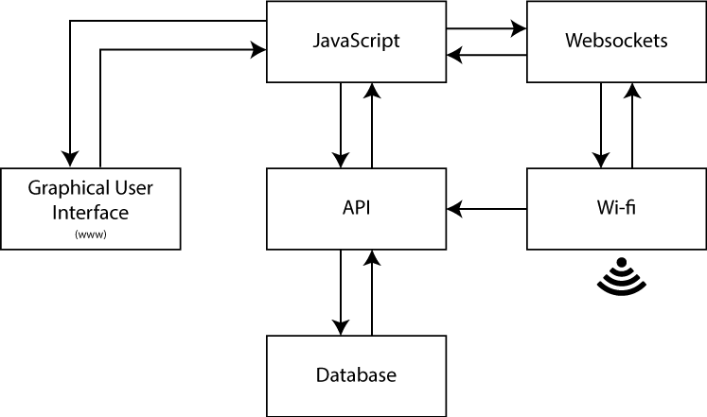

**Figure 3.2: The internet block.**

In our project, we will make a Graphical User Interface (GUI) that will act as a server to forward any data to or from the remote device and main control. This web interface will consist of some buttons that will allow users to turn ON/OFF a device and corresponding sliders to control the power output. In this aspect, the API (Application Programming Interface) will work as a service that will take client’s request from the web browser, forward it to the microcontroller and will receive response from there and serve the client’s request simultaneously. The API will also store the data or information regarding the button press on the page (ON/OFF) on a database. With the help of JavaScript the user can dynamically press a button ON/OFF or can turn the pin high or low on the webpage.

# Summary

Our proposed system will consist of two parts: Hardware and Software. The microcontroller will work as a central hub of the system. The Wi-Fi shield of the system will provide internet connectivity for the embedded micro web server which will allow internet access and will let users to control the devices through a web application. With the help of microcontroller, the users will be able to control devices via a smart device with the use of internet. Our design mainly focuses on controlling the switching of the power outlets that can be used to control various electrical appliances, such as lights and fans or any inductive load that can be voltage regulated. A Zero Crossing Detector and Thyristor based switching circuits will be used for this operation. Our design will propose a low maintenance cost and flexible home control system using smart devices.

Chapter 4: Methodology and Implementation



# Overview

This chapter gives an overview of the different parts of the circuit in brief. It mainly discusses about the requirements, theories, techniques and implementation of the whole system.

# Hardware and Software Requirements

There are certain hardware requirements that need to be met to carry out this project. They are stated below:

* Zero Crossing Detector Module
* Arduino Pro Mini
* ESP8266 Wifi Module
* Current Sensor Module
* Voltage Sensor Module
* Web Application

# Hardware

The following descriptions give an idea about how we implemented different Hardware Modules in our project.

## Zero Crossing Detector (ZCD)

Zero crossing is a term commonly used in electronics, mathematics, image processing and sound. It is the point in a sinusoidal wave, where the mathematical function transits from a positive cycle to a negative cycle, or vice versa. Zero-Crossing detector is a device that is used mainly for measuring the frequency, period, or phase difference of a periodic AC signal by detecting the time period between two or more zero crossing points.

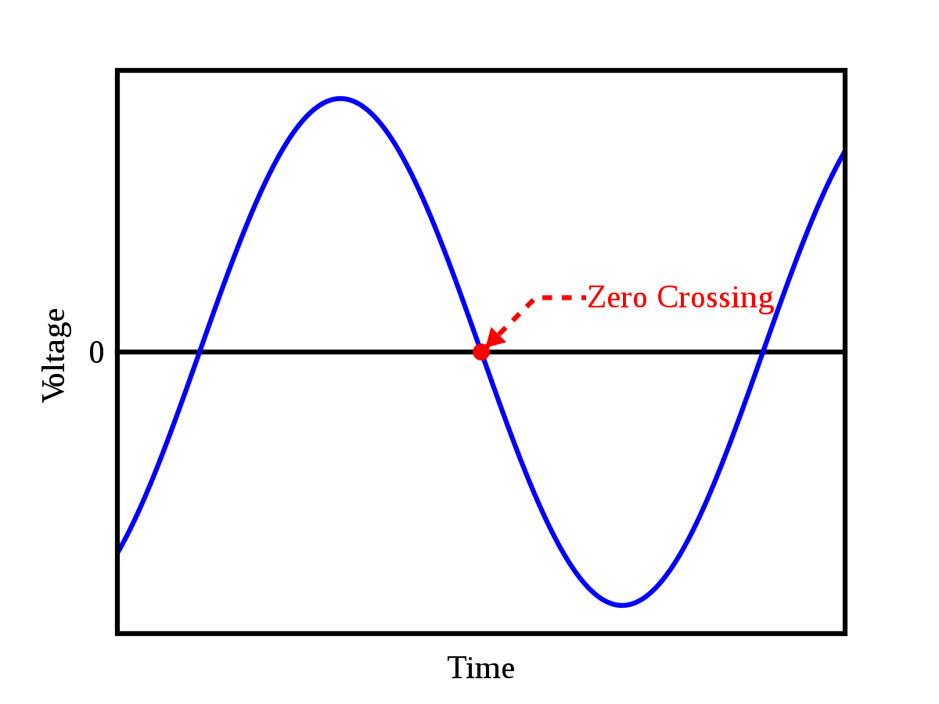

**Figure 4.1:** Zero Crossing point in a sine wave.

There are many methods to detect zero crossing proposed by various authors [8]. Some of them are:

* Zero crossing detection by interpolation – This uses two signals from a single source where one point is found just before the 0V of the main signal and the other point is found right after the 0V of the same signal. These two signals are then interpolated to converge towards a new point that is close to the 0V point. This method required computer processing.

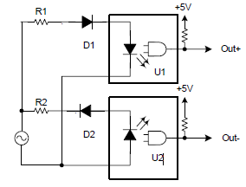

**Figure 4.2a:** Circuit for dual point interpolation method for detecting a zero crossing.

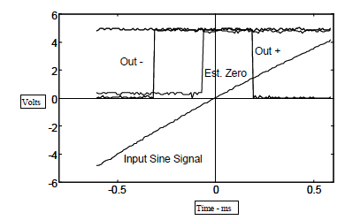

**Figure 4.2b:** Optoisolator outputs and computed zero crossing.

* Comparator circuits with fixed hysteresis – This circuit takes the input of the main signal and compares the voltage with two reference voltages. One that is at zero and another that is close to zero. This prevents multiple zero crossing detection that occurs near the zero crossing point of the sinusoid.

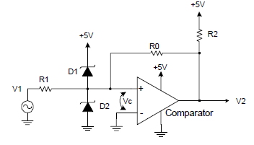

**Figure 4.2c:** Resistive feedback hysteresis circuit.

* Comparator circuits with dynamic hysteresis. – This circuit works just like the fixed hysteresis circuit but has dynamic threshold voltages that further prevent multiple zero crossings. A capacitor is added at the feedback that adds to the positive feedback when the first zero crossing is detected. And then the feedback slowly decays overtime to dynamically change the threshold voltage.

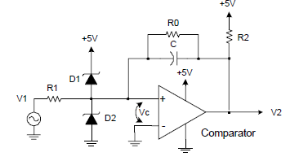

**Figure 4.2d:** Dynamic hysteresis comparator circuit.

This theory is needed to know when a zero crossing is detected; the signal can be delayed at will, using a microcontroller to the input of a TRIAC gate. This will cause the TRIAC to switch on at a different phase of the AC source, hence controlling the output power towards the load.

For the purpose of this project a different approach was taken that was ideal for our application since it had isolated high voltage and low voltage sides. This has an advantage of lowering the risk of damage caused to the micro controller due to a power line fluctuation. And also isolation provides an exception of unwanted noise that may interfere with the micro-controller.



**Figure 4.3:** Zero Crossing Detector.

The 230V AC signal is filtered out and rectified using a full bridge rectifier and then dropped across the 22k ohm resistor to make a voltage divider. The voltage drop across the 22k ohm resistor is approximately 11V. When the sinusoid reached zero the LED in the optocoupler turns off and is on during the rest of the cycle as the capacitor charges and discharges and triggers the transistor on and off. At this stage the signal is still not perfect yet, as the slew rate is much higher and might give wrong results when read from a microcontroller as the interrupt will trigger at rising or falling edge. Thus a Schmitt Trigger was introduced to the circuit to further process the signal. A Schmitt trigger is a bistable circuit in which the output increases to a steady maximum when the input rises above a certain threshold, and decreases almost to zero when the input voltage falls below another threshold. This is how a pure square wave will be achieved to make the signal more stable and precise.

## TRIAC Dimmers

The TRIAC is a three terminal semiconductor device for controlling current. It gains its name from the term **TRI**ode for **A**lternating **C**urrent. It is effectively a development of the SCR or thyristor, but unlike the thyristor which is only able to conduct in one direction, the TRIAC is a bidirectional device.

The TRIAC is an ideal device to use for AC switching applications because it can control the current flow over both halves of an alternating cycle. A thyristor is only able to control them over one half of a cycle. During the remaining half no conduction occurs and accordingly only half the waveform can be utilized.

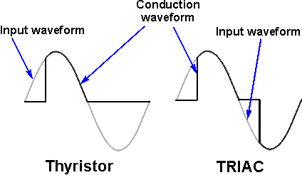

**Figure 4.4: Typical TRIAC & thyristor switching waveforms.**

The circuit symbol recognizes the way in which the TRIAC operates. Seen from the outside it may be viewed as two back to back thyristors and this is what the circuit symbol indicates.

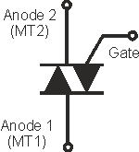

**Figure 4.5: TRIAC symbol for circuit diagrams.**

On the TRIAC symbol there are three terminals. These are the Gate and two other terminals are often referred to as an "Anode" or "Main Terminal". As the TRIAC has two of these they are labeled Anode 1 and Anode 2 or Main Terminal, MT1 and MT2.

The instantaneous pulses from the zero crossing detector is registered by the microcontroller which is then delayed and sent to the gate of the TRIAC at different intervals to change the conduction cycle of the AC waveform at the TRIACs output. This allows the user to change the overall voltage RMS voltage at will.



**Figure 4.6:** TRIAC circuit.

The TRIAC and microcontroller are isolated through an optocoupler. There needs to be a galvanic separation between the microcontroller side and anything connected to the mains. **Galvanic isolation** is a design technique that separates electrical circuits to eliminate stray currents. Signals can pass between **galvanically isolated** circuits, but stray currents, such as differences in ground potential or currents induced by AC power, are blocked. The live wire of the AC mains is connected to one of the anodes of the TRIAC and the load is connected to the other end of TRIAC and the neutral line to complete the circuit. The gate is connected to the TRIAC side of the optocoupler, as the TRIAC inside the optocoupler is not rated for high currents.

## Current sensor

Knowing the amount of current being delivered to a load can be useful in a wide variety of applications. For example, in low-power consumer products the supply current can be monitored to understand the system’s impact on battery life. The load current also can be used to make safety-critical decisions in over-current protection circuits.

Two types of current sensing is usually used, direct and isolated. In this project we will only be working with isolated current sensing which is based on Faraday’s and Ampere’s laws. A coil is placed, for instance a Current Sensor around a current-carrying wire and then a voltage is induced across the coil that is proportional to the current. This allows us to do a non-invasive measurement where the current sensing circuit is not electrically connected to the monitored system, hence not interfering with the entire system.

Direct current sensing is Ohm’s law based. A shunt resistor is placed in series with the system load and then a voltage is generated across the shunt resistor that is proportional to the system’s load current. The voltage across the shunt can be measured by differential amplifiers such as operational amplifiers (op amps). But this method is an invasive measurement as the shunt resistor and sensing circuitry are electrically connected to the system. Therefore, direct sensing typically is used when galvanic isolation is not required. The shunt resistor also consumes some amount of power, which may not be desirable.

This project will be focusing on the current sensing that provides us with galvanic isolation by using a current transformer of 2000:1 ratio.



**Figure 4.7:** using current transformer.

The current coming through the load will be passing through a coil that will generate a voltage in the secondary coil. The goal is to add a DC voltage to the generated voltage so that a microcontroller can read the signal. Any negative voltage is undesirable as the microcontroller can read any voltage that is below 0V. This can damage it or give inaccurate readings. There needs to be a burden resistor across the secondary coil as this defines the output voltage range. This designer needs to choose this resistor according to the current carrying capacitance of the wire and or circuit as well the safe voltage that the ADC can read without damaging it. And also through judgment on how much current will be typically measured for the system. The circuit above solves this problem of a negative voltage by adding a DC offset to the generated voltage on the secondary coil. Two resistors of the same value were placed in series on one of the nodes on the secondary side and was supplied the reference Vcc and Gnd as shown in the circuit diagram. This provides a DC offset of 2.5V (if Vref is 5V) that makes sure the microcontroller can sample all the values. The DC offset is then removed using a simple code, programmed inside the microcontroller that implements a High Pass filter which removes the DC offset.

## Voltage sensor

**AC voltage measurement** is implemented by converting AC voltage into proportional DC Voltage using rectifier and filter circuits, similar to current sensors. Similar to DC voltage measurement Voltage divider is constructed using two 1M Ohm resistors and two 10K resistor to step down the voltage. Two 5V Zener diodes are used to protect Arduino from accidental excess voltages. The 10K resistors need to be chosen wisely for calibrating the voltage that can be read by an ADC. Typically the stepping down of the voltage is achieved using a voltage step down transformer which also provides galvanic isolation. But voltages transformers are usually very bulky and will increase the overall form factor of the whole system along with the cost. This is why it was decided to make one without a transformer as shown in the figure below.



**Figure 4.8:** Voltage sensor.

## Arduino Pro Mini

Arduino is a full blown development board that is an open-source electronics platform which is easy-to-use with its dedicated compiler. Arduino boards are used to write digital outputs or read various analog and digital inputs from various sensors. It operates by telling the board what to do by sending a set of instructions to the onboard microcontroller. To do so, the Arduino programming language (based on Wiring), and the Arduino Software (IDE), is used. There are many boards out there provided by the manufacturer.

And some of the popular ones are:

* Arduino Uno R3
* Arduino Mega
* Arduino Lilypad
* Arduino Nano
* Arduino Pro Mini,etc.

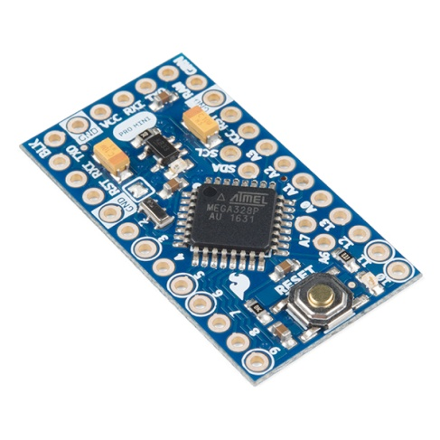

**Figure 4.9:** Arduino Pro Mini.

For this project, mainly the Arduino Pro Mini will be used for its cheap price, small form factor, a desirably large flash memory, speed and availability.

## ESP8266

ESP8266 is a wifi SOC (system on a chip) produced by Espressif Systems. It provides full internet connectivity in a small package in a highly integrated chip design.

ESP8266 is used as an external Wifi module by using the standard AT Command set Firmware, provided as a factory default, by connecting it to any microcontroller using the serial UART, SPI or I2C protocol or directly serve as a Wifi-enabled microcontroller, by programming a new firmware using the provided SDK.

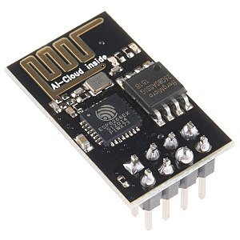

**Figure 4.10:** ESP 8266 Wifi Module.

This board has been around for a few years now, and has been mostly used in IoT applications, where we may want to add connectivity to a Arduino project. It has been adopted widely and is facilitated by a very cheap price, ranging from 190tk to 800tk which depends on the features offered by the manufacturers.

This board is used to transfer and receive various commands to and from the web interface to the Arduino through the UART protocol. This device runs strictly on 3.3V and anything above will damage it and anything below will render it useless, as it requires significant amount of power to stay connected wirelessly. This also was has a feature to wirelessly update the firmware over the air (OTA) that writes the received firmware in the EPROM and flashes it from there. This is extremely helpful for us as the firmware can be updated even after the system has been deployed.

The RX pin needs to be connected to the TX pin of the Arduino through a voltage divider network to ramp it down to 3.3V, since the TX pins on the Arduino supplies 5V. The CH_PD needs to be connected to VCC. The TX pin needs to connect to Arduino’s RX pin (No need for any additional components in between). And all the GND pins need to be connected at a common ground node.

When uploading the code, the GPIO 0 pin needs to be grounded before starting up the module to upload any code. And then reset the module without the ground pin connected for the code to run. This needs to be repeated every time a code is uploaded, i.e, Ground GPIO 0, Start the module, Upload code, take the ground wire off from GPIO 0, Reset. These steps need to be repeated for every consecutive uploads. Making dedicated buttons for ground and reset is advised to make things easier.

# Software

Here we will discuss about the ins and outs of Django to create the web application and then establish a communication between Arduino and ESP8266.

## Web application

Django is written in Python and is a free and open-source web framework that follows the model-view-template (MVT) architectural pattern. Established as an independent non-profit organization, it is maintained by the Django Software Foundation (DSF), Django makes sure that the creation of complex, database-driven websites can be made with ease. It emphasizes reusability and plugging in of components, rapid development, and the principle not repeating the same thing each time a new app is built. Python is used throughout, even for settings files and data models. Django also provides an optional administrative create, read, update and delete interface that is generated dynamically through introspection and configured via admin models.

**Views:** A view function, or view for short, is simply a Python function that takes a Web request and returns a Web response. This response can be the HTML contents of either a Web page, a redirect, a 404 error, an XML document, or an image etc. The view itself contains whatever arbitrary logic is necessary to return that response. This code can live anywhere you want, as long as it’s on your Python path. There’s no other requirement. The convention is to put views in a file called “views.py”, placed inside the project or application directory.

**Models:** A model is the single, definitive source of information about the database. It contains the essential fields and behaviors of the data you're storing. Generally, each model maps to a single database table. The basics: Each model is a Python class that subclasses django.db.models.Model.

These models are use to store the voltage, current, power factor, apparent power and real power information that will be called when the charts are populated inside the HTML files that will be rendered by the views class.

**Application Programming Interface (API):** Application Programming Interface, commonly known as API is a software intermediary that allows two applications or two different programming languages to interact with each other. It is a set of routines, protocols, and tools for building software applications.

**Websockets (Django Channels):** WebSockets represent a long awaited evolution in client/server web technology. They allow a long-held single TCP socket connection to be established between the client and server which allows for bi-directional, full duplex, messages to be instantly distributed with little overhead resulting in a very low latency connection. In other words, Django calls this “Channels”. Channels is a project to make Django able to handle more than just plain HTTP requests, including WebSockets and HTTP2.

**JSON:** Django REST framework is a powerful and flexible toolkit for building Web APIs. The API is created in JSON format for this project because it is very easily encoded and decoded with only a few lines of code before the data is ready for consumption.

## Communication

A stream of JSON text containing the slider information is sent to the webserver that is sending that data to any channel that is connected to it, in this case, the wifi module inside the home automation system. This text is then sent via the UART protocol to the Arduino which the decodes the JSON text into objects and then controls the dimming of the lights by firing the gate of the TRIAC at different user defined intervals proportional to the sliders.

The power data is generated from the Arduino and then encoded into JSON text that is then sent to the ESP8266 wifi module using the same UART protocol via serial. This text is then received and sent to the web server via websockets. Same as previous, the Django channels handle this request and send this text to any consumer that is connected to this link. In this case, the charts app is connected to this channel from where it receives this text and decode the text into JSON objects and then populates the charts.

## Measuring the frequency of AC signal using Zero Crossing Detector

Generally, reading the frequency of the AC signal of the mains is not required as it is mandatory for all power generation companies to maintain a certain frequency all the time. But since a zero crossing detector is being used in our system, it will be a great troubleshooting feature to implement in our system to check if everything is in order. That is, the indication would be, if there is a change in frequency it would be safe to assume that the zero crossing detector might have malfunctioned.

The frequency is measured by the microcontroller by receiving a zero crossing pulse and starting up a counter. The counter will keep running until the next zero crossing point is detected. And then calculate the frequency by inversing the time period that is accumulated by the counter. This measure will give us a frequency of 100Hz if everything is in order, as the zero crossing point occurs twice in a 1 cycle of a 50Hz signal. Thus the frequency read is then divided by 2 to get the main line frequency. A few consecutive reading generated by this method, when averaged, will give us a far more accurate reading.

# Hardware Implementation

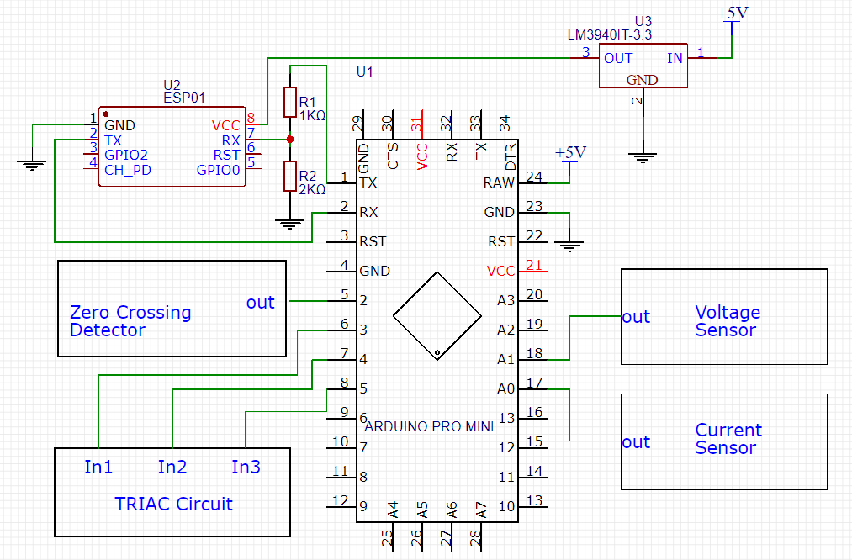

**Figure 4.11:** Pin connections for the modules.

The whole system was ultimately connected as follows:

The zero crossing detector’s output pin was connected to the Arduino’s interrupt pin which is Pin 2. The triggering inputs for the TRIAC circuit was provided by the microcontroller’s pin 3,4 and 5 for 3 different TRIAC switches. The voltages reading coming out from the voltage sensor were connected to the ADC pins of the Arduino A1. Similarly, the current sensor’s output was connected to arduino’s analog input A0. Since the ESP8266 is a 3.3V module, a voltage regulator was used to step down the 5V supply to a 3.3V supply to power the module. The RX pin of the ESP8266 wifi module was connected to the arduino’s TX pin through a voltage divider network as the Arduino gives out a 5V peak voltage that the ESP cannot handle. Thus the voltage divider network effectively converts the voltage to 3.3V peak. The TX pin of the ESP was direct connected to the Arduino that’s gives out a 3.3V peak, but no signal processing is required as the Arduino can read 3.3V peak as a logic HIGH and ground as a logic LOW. The rest of the modules are powered through 5V DC supply, these were not shown to maintain clarity in the schematic. A common ground was used throughout the system.

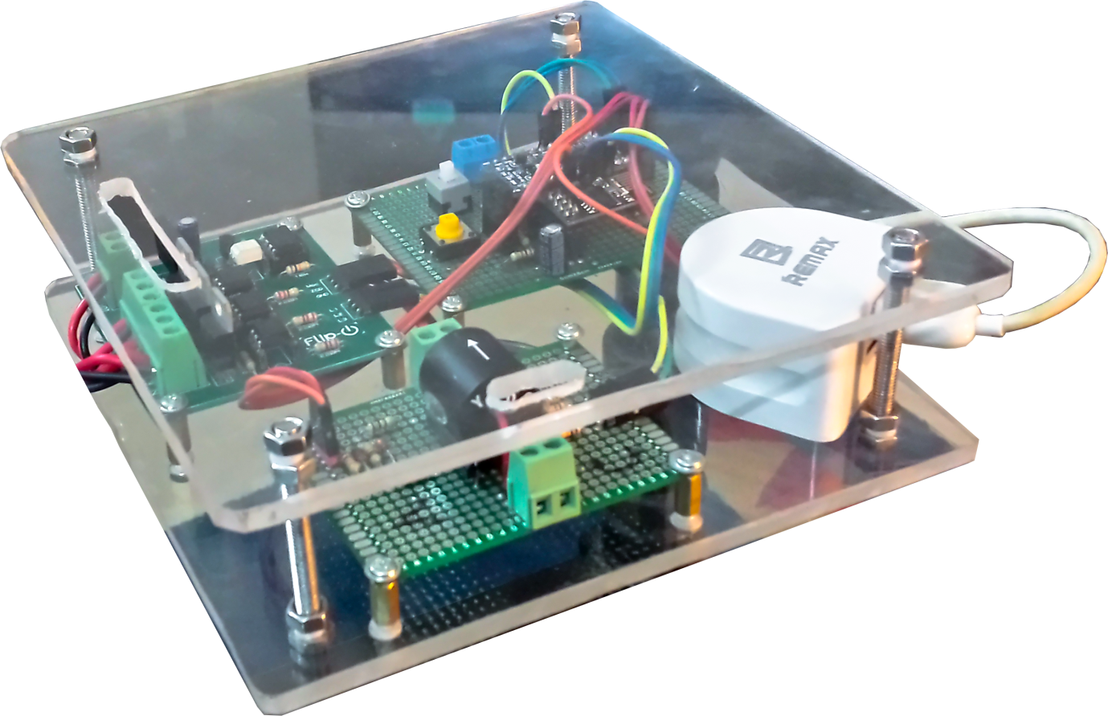

**Figure 4.12:** The complete hardware with integrated 5V power supply

# Software Implementation

At first a template was created using the Django framework where the HTML file was rendered. Then JavaScript was introduced along with JQuery to create the sliders for controlling the home appliances. But these sliders will be useless if they do not send and receive real time data. And thus websockets were implemented using the Django channels. Later the monitoring web app for the power line was implemented using a javascript plug in called HighCharts for a new HTML page. The data inside the charts were populated using the Django REST framework API but then again, the charts were not updating in realtime and had to be refreshed every time to generate new data. Thus websockets were implemented again to populate the charts with new data as soon as a new websocket JSON text was received. An API that is link to a database was also created using the Django Rest Framework to store user history, but was not implemented for this prototype.



**Figure 4.13a:** Landing page

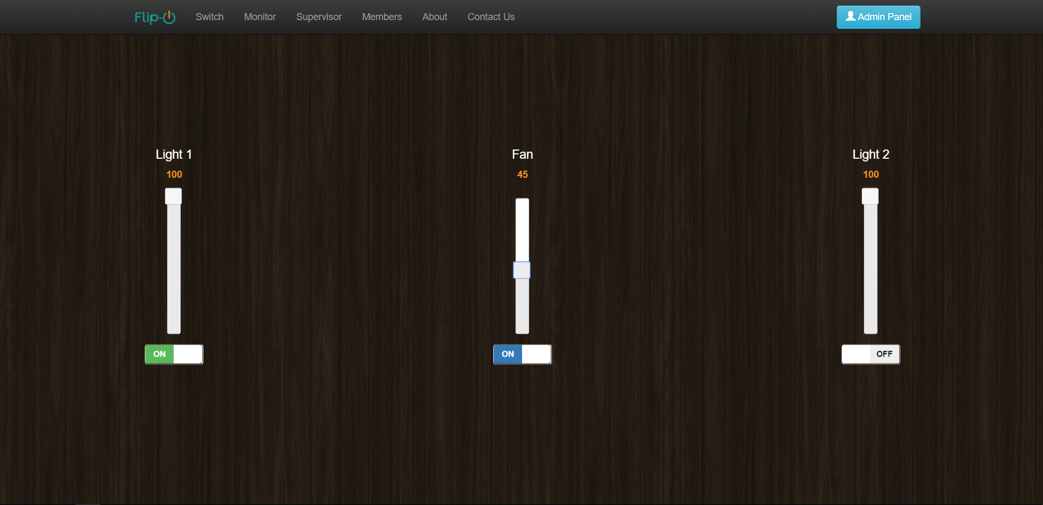

**Figure 4.13b:** User Interface

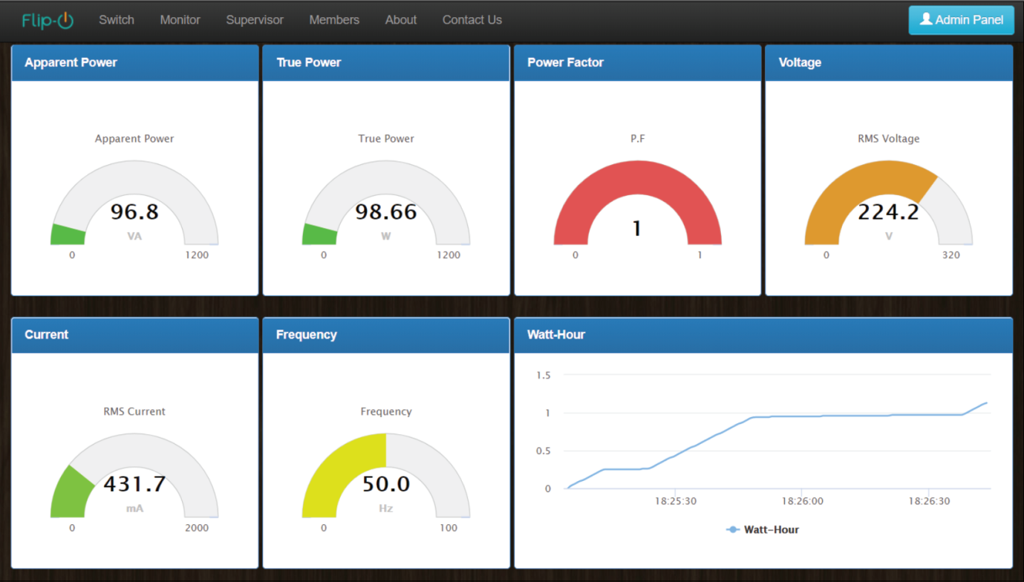

**Figure 4.13c:** Energy Monitoring Interface

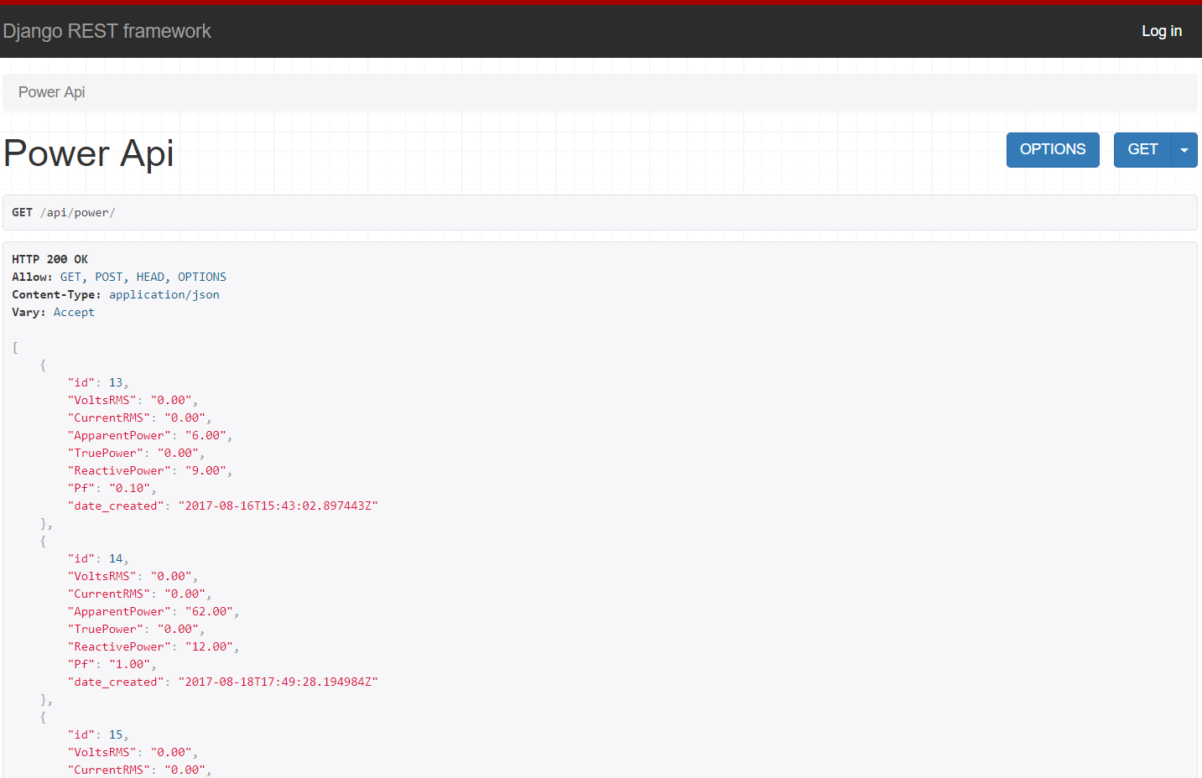

**Figure 4.13d**: API created using the Django REST Framework

# Summary

In this chapter various methods of zero crossing detection was discussed and in the end it was shown how a different version of zero crossing detector was made along with circuit schematics. A schematic of the TRIAC circuit was also given along with a description about how it works with a microcontroller and a zero crossing detector. Implementation of current and voltage sensors were discussed for power calculations. The communication between the hardware and software interfaces was also discussed in details along with the implementation of the web server using the Django framework and its supporting modules. And lastly it was shown how all the different modules were connected to each other using the microcontroller as a brain and worked together to build our project which is an IoT based Home Automation System.

Chapter 5: Results and Testing



# Overview

In this section we’ll looking at the test results of the modules that were built during the whole development process. We’ll be analyzing various graphs and figures of the Zero crossing detector and TRIAC circuits along with the current sensor. We’ll also be talking about the failures that occurred during the conducted experiments and implementations.

# Zero Crossing Detector

The output from the Zero crossing detector as seen through an oscilloscope given below:

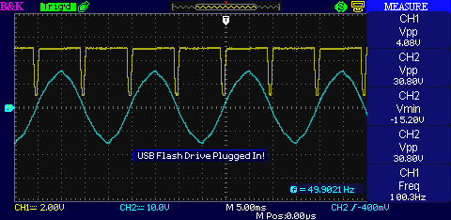

**Figure 5.1a:** Zero Crossing Detector output.

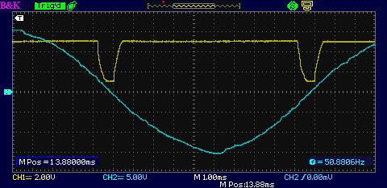

**Figure 5.1b:** Close up look of Zero Crossing Detector.

As seen through the oscilloscope, it is clear that the zero crossing detection is not perfect. There the rise time and the fall time is much higher that usual and is not perfect as there is a exponential rise and fall associated with it. This can be easily misinterpreted by a microcontroller. And hence, to solve this issue, a Schmitt trigger was used and the signal was further processed to get a much better output. The following diagrams show how the signal was read inside the microcontroller before the Schmitt Trigger was added. The values were directly taken from the Arduino’s serial monitor within 500ms time at 115200 baud rate.

**Figure 5.2:** Zero crossing detector output before adding a Schmitt Trigger as read by Arduino.

The table below shows the calculation steps and standard deviation of the zero crossing detection.

|  |  |  |  |  |  |
| --- | --- | --- | --- | --- | --- |
| i | T(ms) | T(s) | Mean | Ti-T(mean) | (Ti-T(mean))^2 |
| 1 | 650 | 0.00065 | 0.000661 | -1.11111E-05 | 1.23457E-10 |
| 2 | 700 | 0.0007 | 0.000661 | 3.88889E-05 | 1.51235E-09 |
| 3 | 600 | 0.0006 | 0.000661 | -6.11111E-05 | 3.73457E-09 |
| 4 | 650 | 0.00065 | 0.000661 | -1.11111E-05 | 1.23457E-10 |
| 5 | 700 | 0.0007 | 0.000661 | 3.88889E-05 | 1.51235E-09 |
| 6 | 700 | 0.0007 | 0.000661 | 3.88889E-05 | 1.51235E-09 |
| 7 | 650 | 0.00065 | 0.000661 | -1.11111E-05 | 1.23457E-10 |
| 8 | 600 | 0.0006 | 0.000661 | -6.11111E-05 | 3.73457E-09 |
| 9 | 700 | 0.0007 | 0.000661 | 3.88889E-05 | 1.51235E-09 |
| SUM | 5950 | 0.00595 |  | 6.50521E-19 | 1.38889E-08 |
|  |  |  |  |  |  |
|  | Mean = |  | 0.000661 |  |  |
|  | Variance= |  | 1.74E-09 |  |  |
|  | Standard Deviation= | | 4.17E-05 |  |  |

**Table 1:** Sample values with steps to find the standard deviation

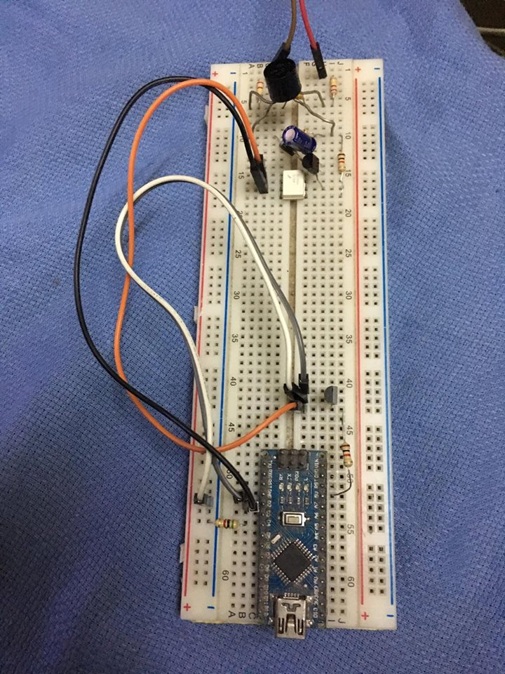

**Figure 5.3:** Zero Crossing detector implemented on a breadboard for the first time.

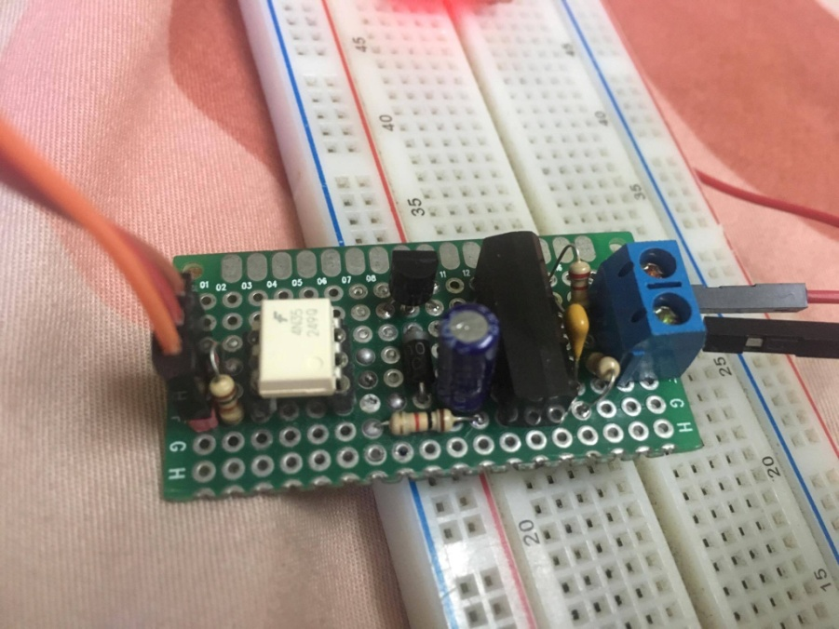

**Figure 5.4:** Prototype of the first Zero Crossing detector.

# TRIAC circuit

The fact that the TRIAC can be used to control current switching on both halves of an alternating waveform allows much better power utilization. However the TRIAC is not always as convenient for some high power applications where its switching is more difficult. TRIACs tend to misfire due to highly capacitive loads and stay ON all the time since the voltage sometimes don’t fall below the turn off thresholds. And because of this, the zero crossing detectors are also affected and does not produce a spike at supposedly zero crossing points.

TRIACs are also incapable of getting damaged due to highly inductive loads as well. Since they are turned on and off very fast at a 100hz frequency, at 50% conduction cycle, inductive loads can create large voltage spikes in the TRIAC which may damage it. This was solved by adding a snubber circuit parallel to the switch. Snubbers are just typical low pass filters that opposes any inductive spikes. They are connected in parallel to the TRIAC and are simply made up of a resistor and a capacitor. But the problem with this circuit is, the resistors need to be able to handle greater than or equal to 1W of power dissipation, which makes it big and the capacitors need to be rated at least 230V, and hence making it bigger as well. Mylar Capacitors are used for this kind of applications. But this external RC snubber was avoided by using the Snubberless TRIACs that has this feature built inside the IC. For this case the BTB04-600B was used that was capable of driving upto 4 ampre consuming load according to the datasheet.

# Current Sensor

The current sensor was tested in comparison with the traditional ammeters at different conduction cycles of an AC wave form at a 10% increment. Traditional ammeters are good at measuring pure sinusoidal waves as they average out the signal to finally give us a reading. But our system uses a microcontroller to sample each points of the AC wave and finds the Root-Mean-Squared value of the signal. And hence is it more accurate than traditional ammeters. The graph below show the currents reading from our system and the current read from a traditional ammeter. It can be seen that the RMS system is more linear at distorted sinusoidal waves than the traditional ammeters.

**Figure 5.5:** Comparison between traditional Ammeter and our system.

# Simulation

The proteus simulation was done to check and compare the output of the raw ZCD values and the processed Schmitt trigger output. As the results show, the raw ZCD value, even in simulation is showing a distorted pulse, where as the Schmitt Trigger output is more uniform and has a constant rise time and fall time all throughout the cycles. This is desirable as the microcontroller is set to identify the zero crossing pulses through edge triggering interrupt will be able to read the signal without any issue. The Schmitt trigger will also somewhat be able to eliminate any false zero crossing detection which is caused due to noise associated with the mains AC signal.

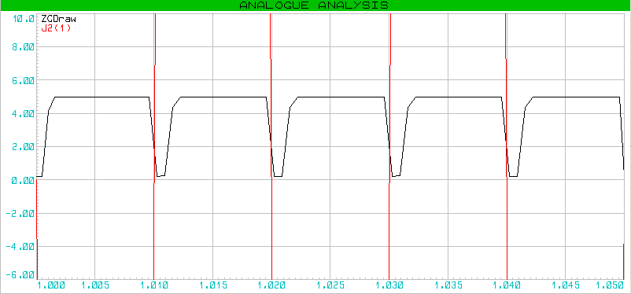

**Figure 5.6a:** The Zero Crossing Detector output without a Schmitt Trigger.

The figure above shows the output of the zero crossing detector without a Schmitt trigger stage. The figure below shows the output when a Schmitt trigger stage is applied. The red lines show the 230V(rms) AC wave zoomed in and the black curve is the raw zero crossing detector value. The blue curve is the Zero crossing detection after a Schmitt trigger was applied.

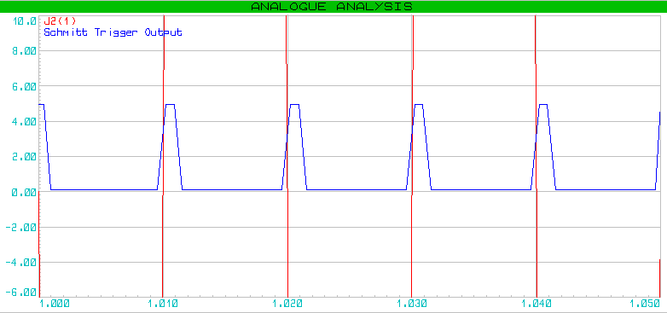

**Figure 5.6b:** The Zero Crossing Detector output with a Schmitt Trigger.

# Issues

When frequency was measured using a microcontroller but utilizing the zero crossing detector, the frequency was off by approximately 2Hz and it deviated a lot. Later it was discovered that the code written to calculate the frequency was not correct. The algorithm was to start a timer whenever a Zero crossing interrupt routine was initiated and calculated the frequency when the next interrupt was initiated. But the problem was, the timer stopped whenever an interrupt was initiated and hence the calculations using those timer counts gave us a wrong frequency. The graph below shows the frequency deviation that was caused by this issue.

**Figure 5.7:** AC Mains Frequency Deviation.

# Summary

This chapter discussed about the test results circuits that were built during the whole development process. We analyzed various graphs and figures of the Zero crossing detector and the current sensor. We have also mentioned the failures that occurred during the conducted experiments and implementations.

Chapter 6: PCB Design



# Overview

In this section, we will be looking at the PCB designs that were made to create the modules using Proteus 8 Profession and LochMaster 4.0 for making easy arrangement of the components on a Strip boards, also knows as Vero Boards, Perf boards, prototyping boards, etc.

# PCB Designs

Below is the PCB design for 1 Zero Crossing detector and 3 TRIAC Circuits designed to be etched together on one board. The design was etched on a single layer copper clad board that had dimensions of 2300 x 2625 thousandth of an inch.

## Zero Crossing Detector and TRIAC circuit:

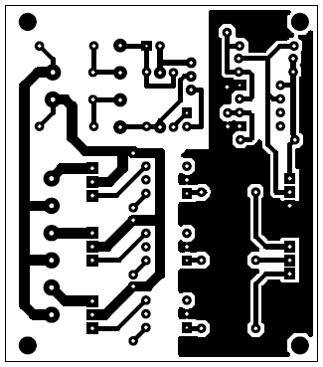

**Figure 6.1a**: Bottom copper layer

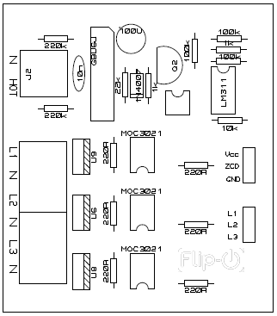

**Figure 6.1b**: Top silk layer



**Figure 6.1c**: Bottom resist layer

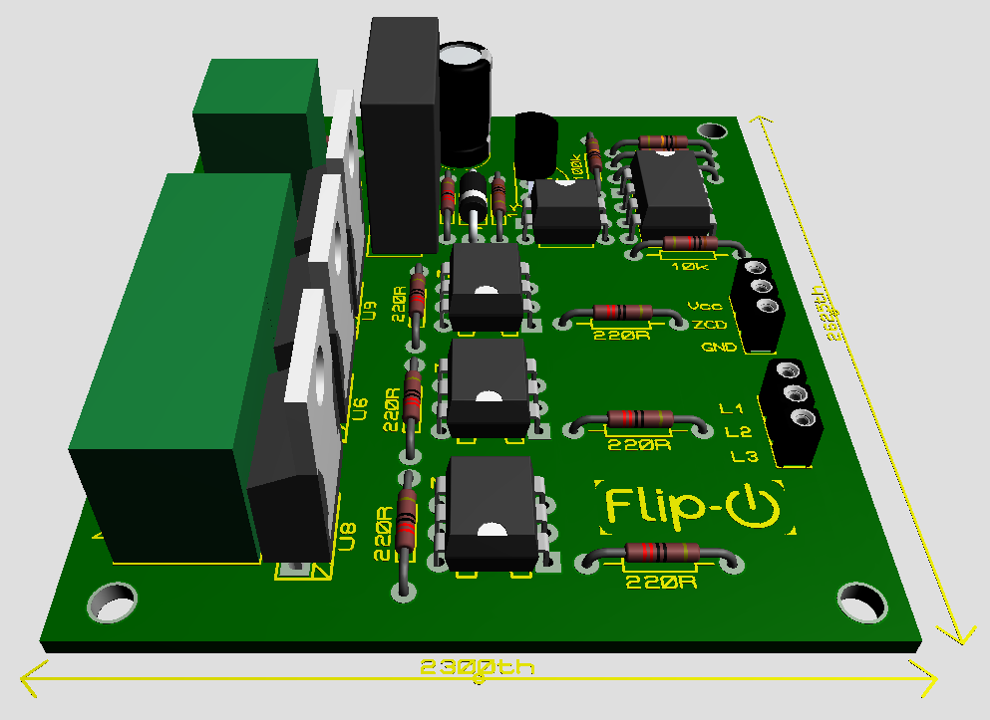

**Figure 6.1d:** 3D view of the Zero crossing detector and TRIAC circuit Module

# Perf Board Designs:

Below are the arrangements plans for the perf board designs for the Voltage and Current sensors together on one board, along with the arrangement plan for the Arduino and the ESP8266. The designs were done using LochMaster 4.0.

## Current and Voltage Sensors:

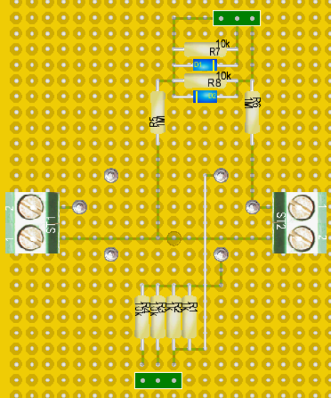

**Figure 6.2a**: Top view of the current and voltage sensors.

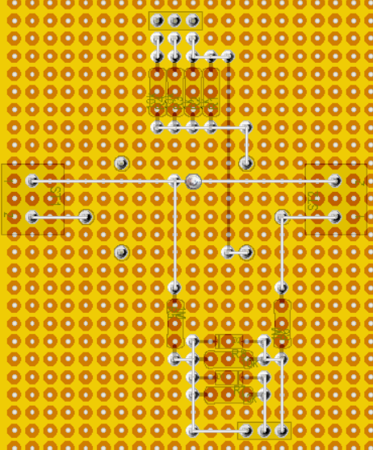  
**Figure 6.2b**: Bottom view for the current and voltage sensors.

## Arduino and ESP8266:

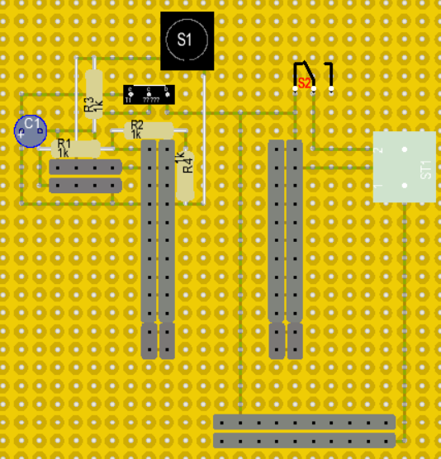

**Figure 6.3a**: Top view of Arduino and ESP8266 module

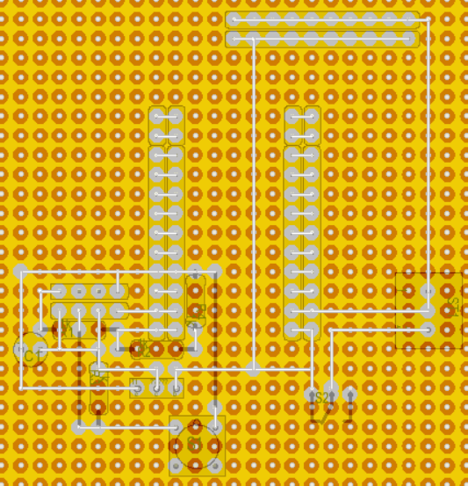

**Figure 6.3b**: Bottom view of Arduino and ESP8266 module

# Summary

In this section various PCB boards and their respective layers were shown, along with the Perf board versions and 3D models of the PCB board that were automatically generated by Proteus 8 professional.

Chapter 7: Device Specification and Installation



# Overview

In this chapter we will be giving an application specific guideline to install the device in a real environment along with the specifications for a smooth user experience. We will talk about how to connect the hardware in a user’s apartment or room, walk through the initial setup process and how one would control and monitor the appliances using the web interface.

# Features:

* Low Cost
* Remote Access
* Compact Design
* Easy and fast Installation
* IoT enabled
* Accessible from all internet enabled devices

# Specifications

* Each load can draw up to 200W of power (Tested).
* Up to 3 loads can be connected
* 230V 50Hz power line (Tested)
* 5V 2A DC supply

# Setup

Before setting up the devices, two crucial things need to be taken in account. One needs to know how the house is wired and to take certain precautions or be careful when dealing with high voltage circuitry. One accidental touch on the wrong wire may prove to be leathal. Once an individual has followed all the guidelines and taken necessary precautions, he or she may proceed to interface the Home Automation System to his or her room.

## Understanding the indoor wiring

Almost every residential space is internally wired the same way. That is, the electrical appliances are connected through dedicated switches with the Live wire and all neutral wires are connected directly to the mains Neutral node. This makes thing easier to connect different electrical appliances without cluttering the limited space inside the switch board as connecting only one wire to each switch is enough to control the home appliances. This also makes things easier for us to interface our hardware. The diagram below shows the internal wiring of a 2-lights and 1-fan room setting.

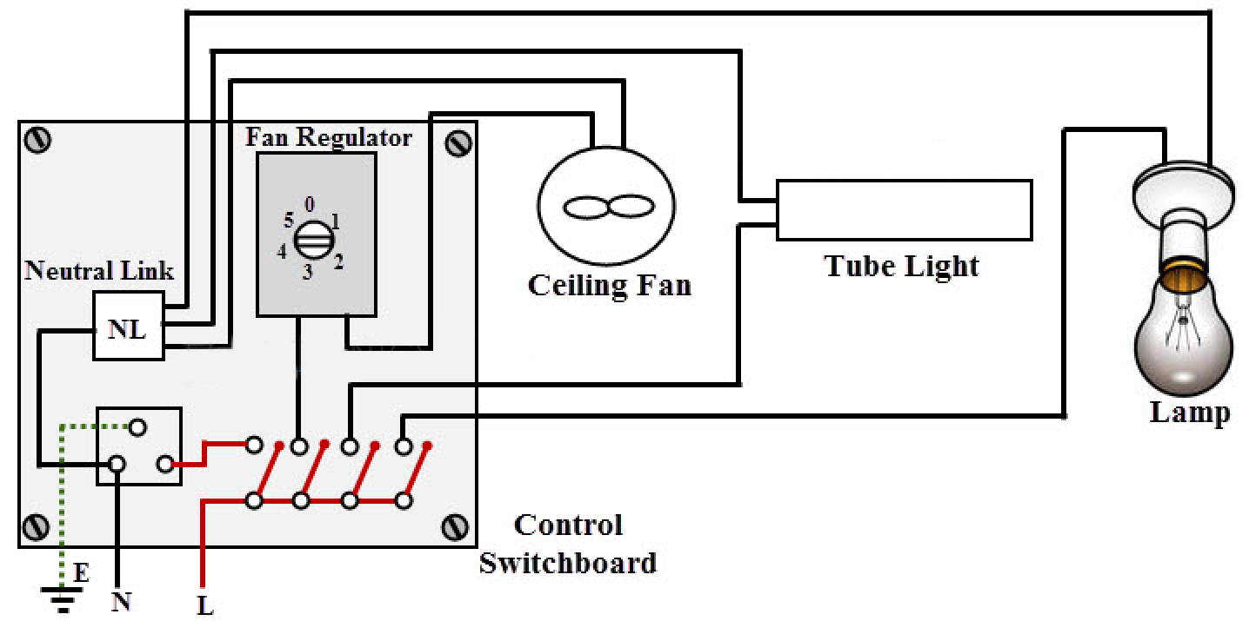

Figure 7.1: Internal electrical wiring of a typical residence

## Electrical Safety

Before starting any installation work, first and foremost thing is the concern of safety of the personnel. Electricity is dangerous, direct or indirect contact of electrical equipment or wires with the power turned ON can result serious injuries or sometimes even causes to death. Follow the below steps to maintain the safety at the workplace.

* Always use safety equipment like goggles, gloves, shoes, etc.
* Avoid direct contact with live or energized circuits.
* Have technical skills to identify exposed live parts of the electrical equipment.
* Make sure the source supply is disconnected while installing or connecting wires.
* The power supplied to the hardware unit must be controlled on the main switchboard which should consist of circuit breaker.
* Conductive tools and materials must be kept far away at a safe distance from live parts of the circuit.

## Installation Guide

1. Open the switchboard and indentify the Live and Neutral wire.
2. Take the wire out from that respective switches that is coming directly coming from the appliances lights and fan.
3. Connect those wires to the Home Automation system where it is labled L1, L2 and L3, which stands for Load 1, Load 2 and Load 3.
4. Since the Neutral wires of the loads are already connected internally through the conduit there is no need to connect it to the system. But incase it’s not connected, Neutral terminals on the system is provided next to their respective Load terminals.
5. After all the loads are connected, attach the live and neutral wires to the Energy Measurement module labeled **L** and **N** for **Live** and **Neutral** link.

**Warning!** Do not mix up the Live and Neutral link as this may cause a short circuit, fire hazards and/or a malfunction of the energy module.

1. As of now, there is no user interface for a user to connect to any user defined WiFi network. Thus, the only way to connect is by hard coding the wifi SSID and password into the Flash memory of the ESP8266 wifi module.
2. Once all of the above steps are done, connect to the designated IP address of the local or external server and start monitoring and controlling the desired electrical appliances.

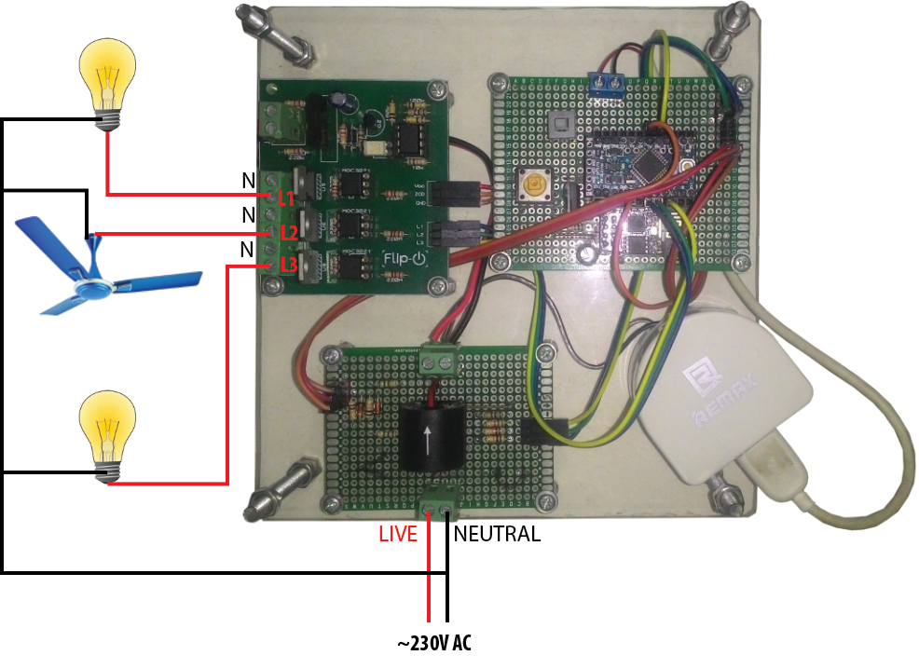

Figure 7.2: Installation

## Performance

* The device performed as expect with a high success rate when tested indoors.
* Continuously ran the system for 4-5 hours per day for a week. Throughout this time the ESP got disconnected only 3-4 times in total due to an unknown unidentified error.
* When tested outdoors, with a lot of interference within the 2.4GHz bandwidth, the device kept disconnecting more frequently. One more probable cause of this could be that the fact that a low end cell phone was acting as the wifi router for the web server, client and the hardware.
* Fine tuning and calibration need to be done for the energy metering module to perfectly measure the power consumptions, and hence accurately measure the cost associated with the power consumption.

# Summary

A brief explanation and visualization was given about the typical indoor electrical wiring. Some electrical safety guidelines were also provided. And finally, this chapter discussed on how to connect the Home Automation system to a household and how to operate the device after the initial installation.

Chapter 8: Discussion



# Overview

In this chapter, we are going to explain about - the total cost of all the tools used in our project, some of the limitations or challenges related to our project and how we can make our system more efficient by doing further developments in the future.

# Cost Analysis

The following table shows the cost of each tool used in our project along with its quantity and also shows the total cost for the whole unit.

|  |  |  |
| --- | --- | --- |
| **Materials** | **Quantity** | **Price(Taka)** |
| **Arduino Pro Mini** | **1** | **180** |
| **ESP8266 (01)** | **1** | **220** |
| **Current Transformer** | **1** | **125** |
| **5.1V Zener Diodes** | **2** | **6** |
| **BTA-04 600B** | **3** | **150** |
| **MOC3021** | **3** | **45** |
| **Full Bridge Rectifier** | **1** | **16** |
| **EL817 Optocoupler** | **1** | **4** |
| **LM311 Comparator** | **1** | **15** |
| **NPN transistor 2N2222A** | **1** | **1** |
| **Diodes, Resistors, Capacitors** | **33** | **50** |
| **Terminal Blocks** | **7** | **28** |
| **PCB** | **3** | **250** |
| **Headers** | **1** | **10** |
| **Total** |  | **1100** |

**Table 2: Breakdown of the cost of equipments used in this project.**

From the table above, we can see that the total cost of a single unit comes to 1100tk only which is quite cheaper than the existing solutions for the home automation in Bangladesh at present. At the initial stage of planning this project we kept in mind some features our system will provide. One of those features would be to make a cost efficient system which could be affordable for the people to buy our product. Throughout the project we had tried to minimize the cost as much as possible and at the same time making sure our circuits meets their demand and work efficiently.

We believe that we have successfully minimized the cost and at the same time tried to make the system simple so that it can be easily implemented practically in Bangladesh.

# Future work

Some of the future developments of our IoT based Home Automation system, are listed below:

* Security issues need to be sorted. For example, password protected module.
* Using MOSFETS instead of TRIACS for better efficiency.
* More features to be added such as, motion sensors, cameras and Artificial Intelligence.
* Make it more optimum for LED lights.
* Make it modular. User can add on more units to existing ones under the same network.
* Implementing power factor correction for energy saving applications.

# Limitations

Our system has some limitations as well. These limitations are as follows:

* Not compatible with CFLs and regular LED bulbs.
* No security features have been added to the web server as of yet. At the moment, there is no authentication system implemented, so the whole system is prone to security risks.
* This module is rated for 240V, 4A AC power systems only.

# Conclusion

Our report represents the application of IoT based Home Automation System using Semiconductor which includes Zero Crossing Detector, thyristor based switching circuit to control the power output to the load and also a web server along with database and API functionality. Our system will enable people to control and monitor various electrical devices via home automation devices from anyplace, at any time. For example; users can dim up or down or can switch on and off their home appliances such as, lights, fans etc through our web interface using internet. In today’s communication technology world, communication is not only confined between two computers only, but it is a complete network called Internet. As IoT (Internet of Things) is bringing new technological changes in our daily lives and making our lives comfortable, so this IoT based Home Automation system can also help users to make their lives simple and convenient. This design will be highly demanding in the near future as our country is becoming developed day by day and in that case everyone will become very busy with their daily work. This design will enable people to automate their homes having remote access to the appliances. This system will also be helpful for the physically challenged or disabled people to use. We are looking forward to adding some security features to our system, also, to diversify this project we can add some other extra features such as; motion sensors, password protection, cameras, Artificial Intelligence etc. We made our system simple so that the ordinary people can easily understand the concept and be able to operate this system. Our built product will be quite affordable for users than other existing solutions of home automation system in this country. In future, this product may have high potential for marketing.

APPENDIX

Arduino and ESP8266 codes

## Arduino Code:

#include "Dimmer.h"

#include <ArduinoJson.h>

#include "EmonLib.h"

#define mySerial Serial

long unsigned int previousMillis=0;

////////////json//////////////////

String rawTxt;

String powerJson;

unsigned int slider1=0;

unsigned int slider2=0;

unsigned int slider3=0;

bool button1 = false;

bool button2 = false;

bool button3 = false;

////////////Dimmer///////////////

Dimmer dimmers[] = {

Dimmer(4, DIMMER_RAMP, .1),

Dimmer(5, DIMMER_RAMP, .1),

Dimmer(6, DIMMER_RAMP, .1),

};

EnergyMonitor emon;

void jsonParsing(){

StaticJsonBuffer<200> jsonBuffer;

JsonObject& sw = jsonBuffer.parseObject(rawTxt);

if (sw.success())

{

slider1=sw["S1"];

slider2=sw["S2"];

slider3=sw["S3"];

button1 = sw["B1"];

button2 = sw["B2"];

button3 = sw["B3"];

}

}

void jsonEncoding(){

StaticJsonBuffer<200> jsonBuffer;

JsonObject& power = jsonBuffer.createObject();

power["TruePower"]=emon.realPower;

power["ApparentPower"]=emon.apparentPower;

power["Frequency"]=50;

power["PowerFactor"]=emon.powerFactor;

power["Vrms"]=emon.Vrms;

power["Irms"]=emon.Irms;

if (millis()-previousMillis>1000){

power.printTo(mySerial);

mySerial.println();

previousMillis=millis();

}

}

void setup() {

emon.voltage(A1, 395, 1.7); // Voltage: input pin, calibration, phase_shift

emon.current(A0, 3.75);

Serial.begin(38400);

while (!Serial) {

; // wait for serial port to connect. Needed for native USB port only

}

for(int i = 0; i < sizeof(dimmers) / sizeof(Dimmer); i++) {

dimmers[i].begin();

}

}

void loop() { // run over and over

emon.calcVI(50,20);

jsonEncoding();

if (mySerial.available()) {

rawTxt = mySerial.readStringUntil('\n');

//Serial.println(rawTxt);

jsonParsing();

}

if(button1) dimmers[0].set(slider1);

else dimmers[0].set(0);

if(button2) dimmers[1].set(slider2);

else dimmers[1].set(0);

if(button3) dimmers[2].set(slider3);

else dimmers[2].set(0);

}

## ESP8266 Code:

#include <Arduino.h>

#include <ESP8266WiFi.h>

#include <ESP8266WiFiMulti.h>

#include <WebSocketsClient.h>

#include <Hash.h>

ESP8266WiFiMulti WiFiMulti;

WebSocketsClient switches;

WebSocketsClient charts;

#define USE_SERIAL Serial

String rawTxt="{\"TruePower\":0,\"ApparentPower\":0,\"Frequency\":0,\"PowerFactor\":0,\"Vrms\":0,\"Irms\":0}";

long unsigned int thisTime;

void switchesEvent(WStype_t type, uint8_t * payload, size_t length) {

switch(type) {

case WStype_DISCONNECTED:

USE_SERIAL.printf("[WSc] Switches Disconnected!\n");

break;

case WStype_CONNECTED: {

switches.sendTXT("Connected to Switches");

}

break;

case WStype_TEXT:

USE_SERIAL.println((char*)payload);

break;

case WStype_BIN:

USE_SERIAL.printf("[WSc] get binary length: %u\n", length);

hexdump(payload, length);

break;

}

}

void chartsEvent(WStype_t type, uint8_t * payload, size_t length) {

switch(type) {

case WStype_DISCONNECTED:

USE_SERIAL.printf("[WSc] Charts Disconnected!\n");

break;

case WStype_CONNECTED: {

charts.sendTXT("Connected to Charts");

}

break;

case WStype_TEXT:

charts.sendTXT(rawTxt);

break;

case WStype_BIN:

USE_SERIAL.printf("[WSc] get binary length: %u\n", length);

hexdump(payload, length);

break;

}

}

void setup() {

USE_SERIAL.begin(38400);

//Serial.setDebugOutput(true);

//USE_SERIAL.setDebugOutput(true);

USE_SERIAL.println();

USE_SERIAL.println();

USE_SERIAL.println();

for(uint8_t t = 4; t > 0; t--) {

USE_SERIAL.printf("[SETUP] BOOT WAIT %d...\n", t);

USE_SERIAL.flush();

delay(1000);

}

WiFiMulti.addAP("FLIP IO", "capstone2017");

//WiFi.disconnect();

while(WiFiMulti.run() != WL_CONNECTED) {

delay(100);

}

// server address, port and URL

switches.begin("192.168.43.49", 80, "/switches/");

charts.begin("192.168.43.49", 80, "/charts/");

// event handler

switches.onEvent(switchesEvent);

charts.onEvent(chartsEvent);

// try ever 5000 again if connection has failed

switches.setReconnectInterval(5000);

charts.setReconnectInterval(5000);

thisTime=millis();

}

void loop() {

switches.loop();

if (USE_SERIAL.available())

{

char recieved = USE_SERIAL.read();

if (recieved == '\n')

{

charts.loop();

rawTxt = "";

}

else rawTxt += recieved;

}

}

# References

[1] The history of smart homes - http://www.afcdud.com/fr/smart-city/422-how-the-history-of-smart-homes.html

[2] Ravi Kishore Kodali et al, IoT Based Smart Security and Home Automation System, International Conference on Computing, Communication and Automation.

[3] Kumar Mandula et al, Mobile based Horne Automation using Internet of Things(IoT), 2015 International Conference on Control, lnstrumentation, Communication and Computational Technologies.

[4] R. Baris Dai et al, A Dimmer Circuit for Various Lighting Devices, IEEE conference

paper.

[5] Jong-Hyun Kim at al , A Simple Dimmer Using a MOSFET for AC Drive Lamp, IEEE conference paper.

[6] ZigBee Home Automation Market to Grow at 26% CAGR to 2020 - https://www.achrnews.com/articles/133443-zigbee-home-automation-market-to-grow-at-26-cagr-to-2020

[7] Article: Ezzy Automation Lunched New Home Automation Device & Fire Alarm Systems to Comfort your Daily Life - http://www.ezzyautomations.com/ezzy-automation-lunched-new-home-automation-device-fire-alarm-systems-to-comfort-your-daily-life/

[8] R.W. Wall, Simple Methods for Detecting Zero Crossing, IEEE Industrial Electronics Society Conference Paper.